
Project Planning Phase

Project Planning Template (Product Backlog, Sprint Planning, Stories, Story points)

Date | 27 January 2026
Team ID | LTVIP2026TMIDS28465
Project Name | ShopEZ : One-Stop Shop for  Online Purchases
Maximum Marks | 4 Marks

Product Backlog, Sprint Schedule, and Estimation (4 Marks)
Use the below template to create product backlog and sprint schedule
Sprint | Functional  Requirement  (Epic) | User  Story  Number | User Story / Task | Story  Points | Priority | Team  Members
Sprint1 | Registration | USN-1 | As a user, I can register for the application by entering my email, password, and confirming my password. | 2 | High | Damera  Sai Sreeja
Sprint1 | Registration | USN-2 | As a user, I will receive confirmation email once I | 1 | High | Gowru  S
Sprint | Functional Requirement (Epic) | User  Story  Number | User Story / Task | Story  Points | Priority | Team  Members
 |  |  | have registered for the application
Sprint2 | Registration | USN-3 | As a user, I can register for the application through Facebook | 2 | Low | B Yoshik
Sprint1 | Registration | USN-4 | As a user, I can register for the application through Gmail | 2 | Medium
Sprint-  1 | Login | USN-5 | As a user, I can log into the application by entering email & password | 1 | High | Kandati  Vadana
 | Dashboard

Velocity:
Imagine we have a 10-day sprint duration, and the velocity of the team is 20 (points per sprint). Let’s calculate the team’s average velocity (AV) per iteration unit (story points per day)
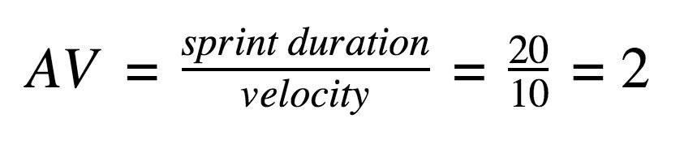

ShopEZ – Burndown Chart Overview
A Burndown Chart is a visual tool that tracks the amount of work remaining in your project (measured in story points) against time (measured in days or sprints). It helps your team stay on track and identify bottlenecks early.
It Works for ShopEZ
- X-Axis (Time): Each sprint (e.g., Sprint-1 to Sprint-4, each lasting 6 days)
- Y-Axis (Work Remaining): Total story points (e.g., 20 per sprint)
- Ideal Line: A straight line from the total story points to zero, showing expected progress
- Actual Line: Plots real progress based on completed story points
Example: ShopEZ Sprint-1 Burndown Day Planned Remaining Points Actual Remaining Points
Day 1 20 | 20
Day 2 16 | 18
Day 3 12 | 14
Day 4 8 | 10
Day 5 4 | 5
Day 6 0 | 0
This shows your team is on track if the actual line closely follows the ideal line.

